Planning Lesson 5 Real World Planning

[1. Sebastian Introduction](https://classroom.udacity.com/nanodegrees/nd787/parts/300ffbd4-f9f0-4524-84fb-0b24d9d04cc3/modules/0c12632a-b59a-41c1-9694-2b3508f47ce7/lessons/2329f84b-c055-4a9f-88d4-ba8583bd66c2/concepts/b604c4f5-c4ef-49d7-a87d-a058fb7c1d2e)

<https://www.youtube.com/watch?v=uec2ezY4Hnk>

[2. Intro](https://classroom.udacity.com/nanodegrees/nd787/parts/300ffbd4-f9f0-4524-84fb-0b24d9d04cc3/modules/0c12632a-b59a-41c1-9694-2b3508f47ce7/lessons/2329f84b-c055-4a9f-88d4-ba8583bd66c2/concepts/51f779f7-5956-4291-b90c-2bdfe560cdb4)

<https://www.youtube.com/watch?v=E_pDGN3wfS0>

## **A Note on this Lesson**

This lesson is meant to be a rapid survey of a few new techniques. None of what you see in this lesson is required to complete the Nanodegree program, but we thought you might find it interesting.

Don't expect to gain a deep understanding of these techniques from this lesson alone. If you want to really understand these concepts you'll probably have to do some additional exploration on your own. Enjoy!

[3. Constraints](https://classroom.udacity.com/nanodegrees/nd787/parts/300ffbd4-f9f0-4524-84fb-0b24d9d04cc3/modules/0c12632a-b59a-41c1-9694-2b3508f47ce7/lessons/2329f84b-c055-4a9f-88d4-ba8583bd66c2/concepts/fa0eb932-2021-491f-b5fb-d64dabaa895d)

<https://www.youtube.com/watch?v=iDk8ODcGh7s>

[4. Modelling Dynamics](https://classroom.udacity.com/nanodegrees/nd787/parts/300ffbd4-f9f0-4524-84fb-0b24d9d04cc3/modules/0c12632a-b59a-41c1-9694-2b3508f47ce7/lessons/2329f84b-c055-4a9f-88d4-ba8583bd66c2/concepts/c561753a-eb98-460e-b0bb-059cd66c75d2)

<https://www.youtube.com/watch?v=Ozo9tEhFs1s>

[5. Modeling Dynamics Exercise](https://classroom.udacity.com/nanodegrees/nd787/parts/300ffbd4-f9f0-4524-84fb-0b24d9d04cc3/modules/0c12632a-b59a-41c1-9694-2b3508f47ce7/lessons/2329f84b-c055-4a9f-88d4-ba8583bd66c2/concepts/0d9d07fc-4a54-4d3c-9d0c-e1d0a2d8b23f)

# **Modeling Dynamics**

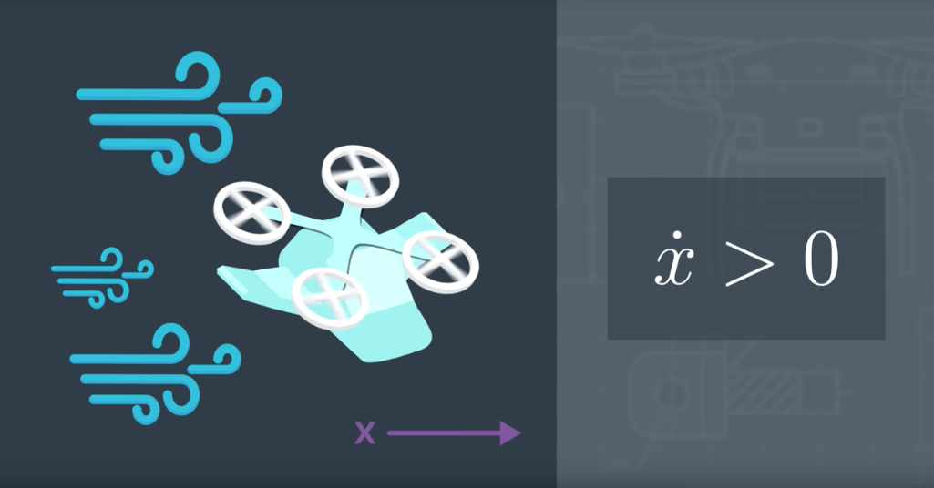

[Dynamics-Model.ipynb](https://view88a94fd0.udacity-student-workspaces.com/notebooks/Dynamics-Model.ipynb)

[6. Dubins Car](https://classroom.udacity.com/nanodegrees/nd787/parts/300ffbd4-f9f0-4524-84fb-0b24d9d04cc3/modules/0c12632a-b59a-41c1-9694-2b3508f47ce7/lessons/2329f84b-c055-4a9f-88d4-ba8583bd66c2/concepts/aab10ec8-b086-419c-a708-81e6996c7730)

<https://www.youtube.com/watch?v=rEMw-qF5V-w>

[7. Dubins Car Exercise](https://classroom.udacity.com/nanodegrees/nd787/parts/300ffbd4-f9f0-4524-84fb-0b24d9d04cc3/modules/0c12632a-b59a-41c1-9694-2b3508f47ce7/lessons/2329f84b-c055-4a9f-88d4-ba8583bd66c2/concepts/3a39e246-1777-4a0e-b0df-6e1f6e48252b)

# **Dubins Car**

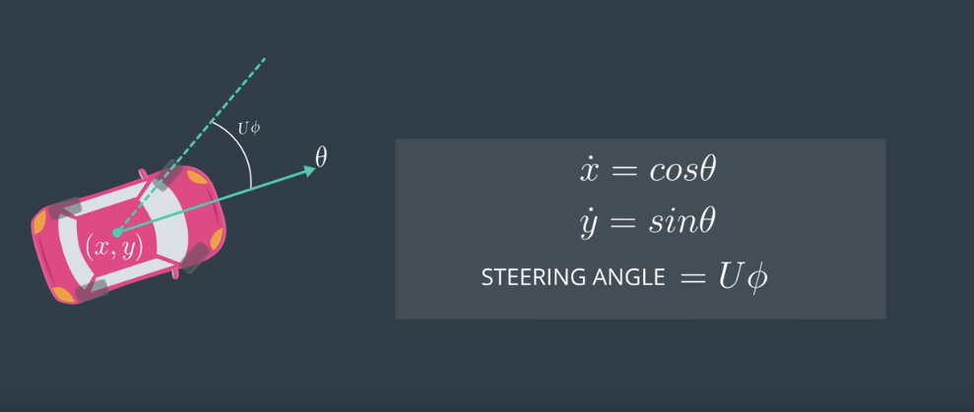

[Dubins-Car.ipynb](https://view5f98f9e5.udacity-student-workspaces.com/notebooks/Dubins-Car.ipynb)

[8. Steering](https://classroom.udacity.com/nanodegrees/nd787/parts/300ffbd4-f9f0-4524-84fb-0b24d9d04cc3/modules/0c12632a-b59a-41c1-9694-2b3508f47ce7/lessons/2329f84b-c055-4a9f-88d4-ba8583bd66c2/concepts/91ecec6b-d33f-431b-a5a9-a054a2305aca)

<https://www.youtube.com/watch?v=eFj0lswWYXo>

[9. Steering Exercise](https://classroom.udacity.com/nanodegrees/nd787/parts/300ffbd4-f9f0-4524-84fb-0b24d9d04cc3/modules/0c12632a-b59a-41c1-9694-2b3508f47ce7/lessons/2329f84b-c055-4a9f-88d4-ba8583bd66c2/concepts/272a3910-9504-40a6-9f33-fd726a77d1c6)

# **Steering**

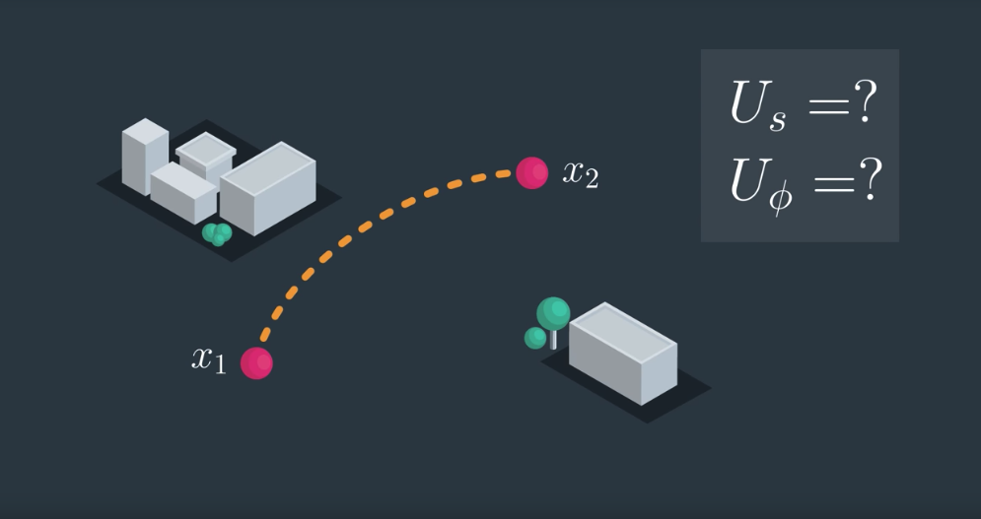

[Steering.ipynb](https://view91507c2e.udacity-student-workspaces.com/notebooks/Steering.ipynb)

[10. RRT](https://classroom.udacity.com/nanodegrees/nd787/parts/300ffbd4-f9f0-4524-84fb-0b24d9d04cc3/modules/0c12632a-b59a-41c1-9694-2b3508f47ce7/lessons/2329f84b-c055-4a9f-88d4-ba8583bd66c2/concepts/cba97816-379d-40f6-b199-607e2edcfd78)

<https://www.youtube.com/watch?v=THpH4DDabZM>

[11. RRT Exercise](https://classroom.udacity.com/nanodegrees/nd787/parts/300ffbd4-f9f0-4524-84fb-0b24d9d04cc3/modules/0c12632a-b59a-41c1-9694-2b3508f47ce7/lessons/2329f84b-c055-4a9f-88d4-ba8583bd66c2/concepts/259e91cd-ed42-4ed4-b9f3-1fa3a85d4399)

# **RRT**

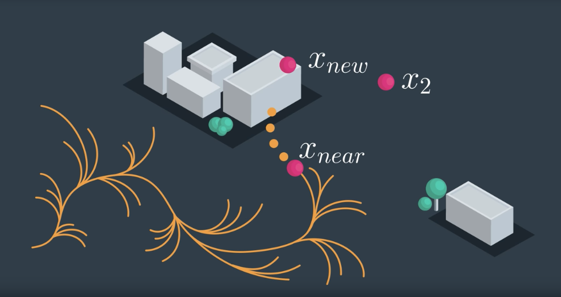

[RRT.ipynb](https://view7716c463.udacity-student-workspaces.com/notebooks/RRT.ipynb)

[12. Adding Obstacles](https://classroom.udacity.com/nanodegrees/nd787/parts/300ffbd4-f9f0-4524-84fb-0b24d9d04cc3/modules/0c12632a-b59a-41c1-9694-2b3508f47ce7/lessons/2329f84b-c055-4a9f-88d4-ba8583bd66c2/concepts/ae6483f1-89ef-42bd-8d4f-9c220fbb7593)

<https://www.youtube.com/watch?v=LEhEGaYFGZs>

[13. Potential Field Planning](https://classroom.udacity.com/nanodegrees/nd787/parts/300ffbd4-f9f0-4524-84fb-0b24d9d04cc3/modules/0c12632a-b59a-41c1-9694-2b3508f47ce7/lessons/2329f84b-c055-4a9f-88d4-ba8583bd66c2/concepts/bd3d5944-7024-466e-93cb-7686ba071dc1)

<https://www.youtube.com/watch?v=4tbyckaBLh4>

[14. Potential Field Exercise](https://classroom.udacity.com/nanodegrees/nd787/parts/300ffbd4-f9f0-4524-84fb-0b24d9d04cc3/modules/0c12632a-b59a-41c1-9694-2b3508f47ce7/lessons/2329f84b-c055-4a9f-88d4-ba8583bd66c2/concepts/cf1025da-d78a-4912-bfd2-82a47e478368)

# **Potential Field Planning**

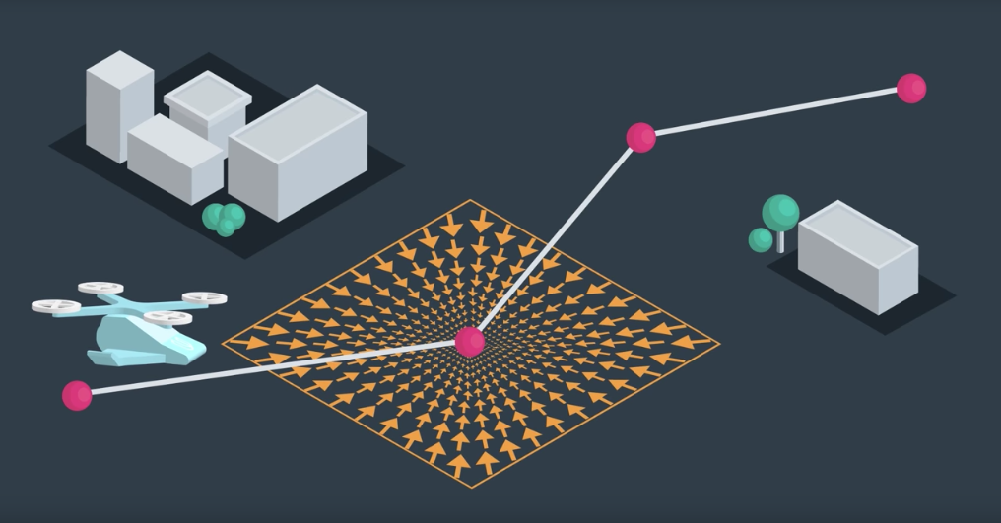

[**Potential-Field.ipynb**](https://viewd03c0af3.udacity-student-workspaces.com/notebooks/Potential-Field.ipynb)

[15. Summary](https://classroom.udacity.com/nanodegrees/nd787/parts/300ffbd4-f9f0-4524-84fb-0b24d9d04cc3/modules/0c12632a-b59a-41c1-9694-2b3508f47ce7/lessons/2329f84b-c055-4a9f-88d4-ba8583bd66c2/concepts/71bb9e29-a9d9-40ab-a02d-6312b7120b2c)

<https://www.youtube.com/watch?v=jWNotyJJpRA>

## **Extended Reading**

At this point, you have the knowledge to read through a recent paper on path planning. The following paper, [Path Planning for Non-Circular Micro Aerial Vehicles in Constrained Environments](https://www.cs.cmu.edu/~maxim/files/pathplanforMAV_icra13.pdf), addresses the problem of path planning for a quadrotor.

It is an enjoyable read that culminates these past few sections of path planning, as it references a number of planning methods that you have learned, and introduces a present-day application of path planning. Reading the paper will help you gain an appreciation for this area of research, as well as help you gain confidence in the subject.

Some additional definitions that you may find helpful while reading the paper:

* **Anytime algorithm**: an anytime algorithm is an algorithm that will return a solution even if it's computation is halted before it finishes searching the entire space. The longer the algorithm plans, the more optimal the solution will be.
* **RRT\***: RRT* is a variant of RRT that tries to smooth the tree branches at every step. It does so by looking to see whether a child node can be swapped with it's parent (or it's parent's parent, etc) to produce a more direct path. The result is a less zig-zaggy and more optimal path.